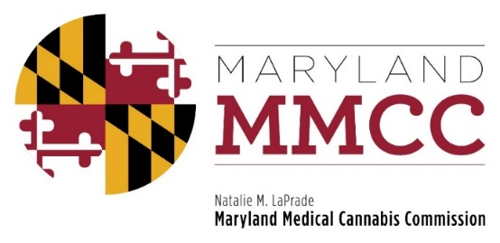
Policy Committee Meeting
Tuesday, September 25, 2018: 1:00 PM
University of Maryland Carey School of Law
Ceremonial Moot Court Room
500 W. Baltimore Street
Baltimore, MD 21201

Agenda

- Call to Order and Welcome
Commissioner J. Charles Smith, Policy Committee Chair

- Advertising Restrictions
- Presentation by Will Tilburg, Director of Policy & Government Relations
- Discussion
- Clinical Director Responsibilities
- Presentation by Will Tilburg, Director of Policy & Government Relations
- Discussion
- Patient ID Cards: Timeline and Implementation
- Presentation by Will Tilburg, Director of Policy & Government Relations
- Public Comment
- Discussion
- Hearing Procedures
- Presentation by Will Tilburg, Director of Policy & Government Relations
- Public Comment
- Discussion
- Good Moral Character
- Introduction by Will Tilburg, Director of Policy & Government Relations
- Public Comment
- Discussion
- New Business

- Adjournment

