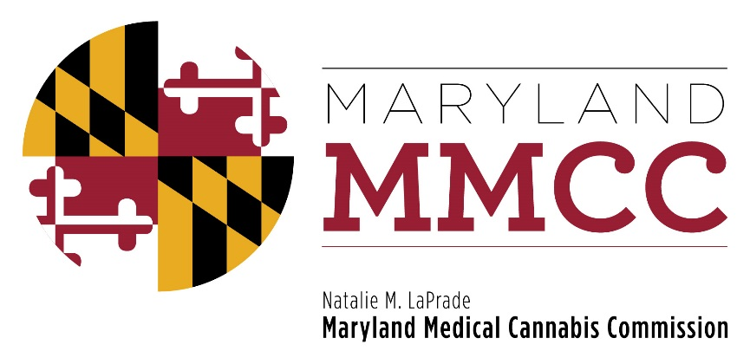
Policy Committee Meeting
Monday, March 12, 2018: 10:00 am
Maryland Health Care Commission
4160 Patterson Avenue, Conference Room 100
Baltimore, MD 21215
AGENDA

- Call to Order and Welcome
Commissioner J. Charles Smith, Policy Committee Chairman

- Approval of the December 14, 2017 Meeting Minutes

- Policy Discussion: Medical/Clinical Director Requirement
- Presentation by Will Tilburg, Director of Policy & Government Relations
- Public Comment
- Discussion
- Policy Discussion: Qualifying Patient Definition
- Presentation by Will Tilburg, Director of Policy & Government Relations
- Public Comment
- Discussion
- Policy Discussion: Certificates of Analyses: Reporting Heavy Metals Data
- Presentation by Will Tilburg, Director of Policy & Government Relations
- Public Comment
- Discussion
- Policy Discussion: Independent Testing Laboratory Fees
- Presentation by Will Tilburg, Director of Policy & Government Relations
- Public Comment
- Discussion
- Policy Discussion: Authorization for Medical Cannabis Pickups
- Presentation by Will Tilburg, Director of Policy & Government Relations
- Public Comment
- Discussion
- Policy Discussion: Definition Revision: Secure Transportation Company
- Presentation by Will Tilburg, Director of Policy & Government Relations
- Public Comment
- Discussion
- Policy Discussion: Definition Revision: Medical Cannabis Secure Transportation Vehicles
- Presentation by Will Tilburg, Director of Policy & Government Relations
- Public Comment
- Discussion
- Policy Discussion: Requiring Registration Cards for All Patients
- Presentation by Will Tilburg, Director of Policy & Government Relations
- Public Comment
- Discussion
- Policy Discussion: Definition Revision: Medical Cannabis-Infused Products
- Presentation by Will Tilburg, Director of Policy & Government Relations
- Public Comment
- Discussion
- Policy Discussion: Revisions to MMCC Organizational Policies
- Presentation by Will Tilburg, Director of Policy & Government Relations
- Discussion

- New Business

- Adjournment

