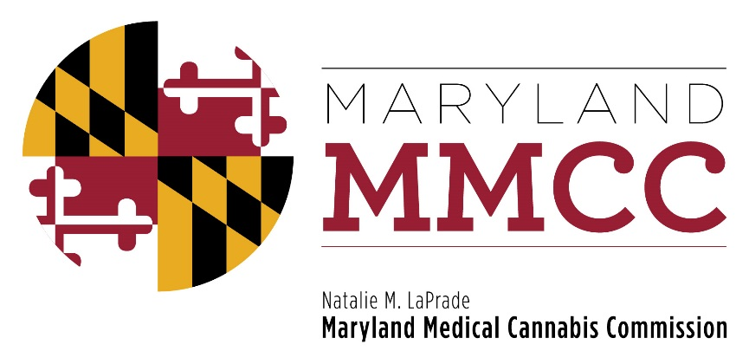
Maryland Medical Cannabis Commission
Committee Meeting
Thursday, May 24, 2018
2:00 pm
Harford County Council Chambers
212 S. Bond Street-1st Floor
Bel Air, MD 21014
AGENDA

- Call to Order and Welcome
Commissioner Brian Lopez, Chairman

- Approval of the April 10, 2018 Meeting Minutes

- Executive Director’s Report: Joy A. Strand, MHA

- House Bill 2 Pre-Approval Requirements: Will Tilburg, Director, Policy & Government Relations

- Committee and Subcommittee Reports:
- Policy Committee: Voting on Proposed Regulatory Changes: Commissioner Charles Smith
- Final Review Subcommittee: Voting on Recommended Licenses and Registrations
- New Business

- Next Full Commission Meeting

- Adjournment

