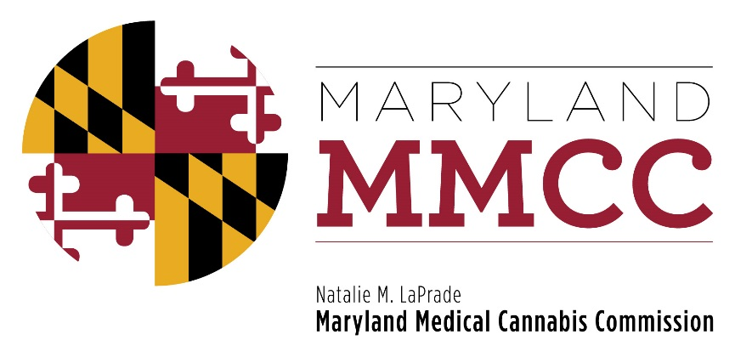
Maryland Medical Cannabis Commission
Policy Committee Meeting
Thursday, December 14, 2017
12:30 pm
Department of Legislative Services Building
Joint Hearing Room, 1st Floor
90 State Circle, Annapolis, MD 21401
AGENDA

- Call to Order and Welcome
Commissioner J. Charles Smith, Policy Committee Chairman

- Approval of the October 23, 2017 Meeting Minutes

- Discussion of Proposed Changes to the Regulations:

- Out-of-State Patients
- Retention Sample Storage and Stability Testing
- Definitions of Standards for Individuals and Entities for Registration and Licensing
- New Business:
Public Comments are requested on the following topics which will be discussed at the next Policy Committee meeting in January, 2018:
  - Clinical Director requirement for Dispensaries
  - CRISP as a repository for medical cannabis-patient information and medical in regard to cannabis amounts and modalities dispensed
  - Defining the frequency of follow-up for medical cannabis patients by the patients’ registered medical providers
  - Defining the scope of practice for authorized medical cannabis providers (Physicians, Dentists, Podiatrists, Nurse Practitioners and Midwives) in regard to recommendations for medical cannabis
- Next Policy Committee Meeting

- Adjournment

