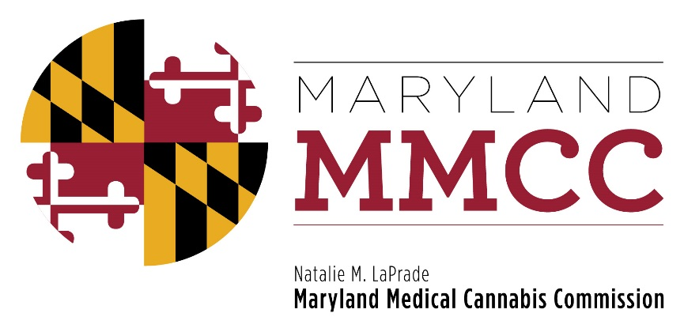
Maryland Medical Cannabis Commission
Policy Committee Meeting
Thursday, September 7, 2017
2:00 pm
Winchester Hall, 1st Floor Meeting Room
12 East Church Street, Frederick, Maryland 21701

A PORTION OF THE MEETING MAY BE CLOSED
TO RECEIVE LEGAL ADVICE FROM COUNSEL

AGENDA

- Call to Order

- Welcome and Introductions:
Commissioner J. Charles Smith III, Chairman of the Policy Committee

- Approval of minutes of May 22, 2017 Policy Committee Meeting

- Amendments to the regulations
  - Independent testing labs
  - Additional certifying providers
  - Additional areas as needed

- Discussion of proposed regulatory changes

- Notice of next Policy Committee Meeting

- Adjournment

